MEMO
To: | University of Guelph | Project No.: | 2025-4003-10 | Date: | 2025-11-21
Attn: | Wes Johnson | Project: | Johnston Hall Tunnel Review
Subject: | Johnston Hall Tunnel Review | From: | Kyle Pellerin

Background and Scope of Services

Walterfedy was engaged by UofG to perform a structural analysis of underground utility tunnels along Alumni Walk at the south side of Johnston Hall at the University of Guelph Main Campus, located on the property at 50 Stone Rd R, Guelph, ON N1G 2W1. It is our understanding that a construction project is underway between Johnston Hall and the Mackinnon Building that required the use of a CX145D SR excavator and a dump truck which would drive over the tunnels shown in figure below.

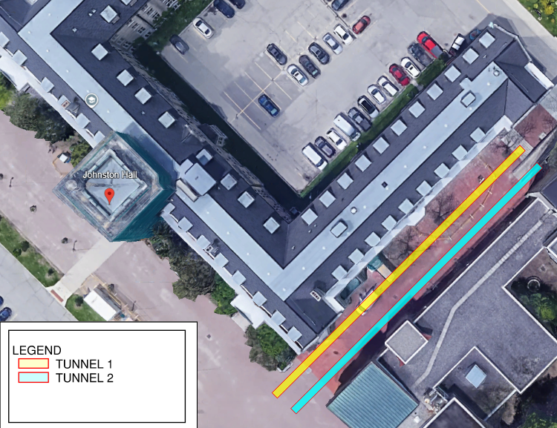

Our scope of services for this work was as follows:
- Review drawings of existing tunnels relevant to the area of work.
- Review loading information of the equipment provided by the contractor.
- Identify capacity of tunnels roofs to support loads and provide a shoring design where required.
- Where shoring was installed, field review of the installed shoring would be performed.

Findings

According to the available record drawing S3-1 by Walterfedy dated 26th April 2010, some sections of “Tunnel 1” were replaced. Locations where the tunnel was replaced was site verified by the contractor performing the work who provided this information to WalterFedy. It was found that areas where the Tunnel 1 roof was replaced was adequate to support loads from the CX145D SR excavator, and the 18000 kg dump truck with a max 6 metric tonne load of concrete. Areas of tunnel 1, and the adjacent Tunnel 2 is not suitable for this loading. Refer two the image below which reflects areas of Tunnel 1 where shoring is required versus not.
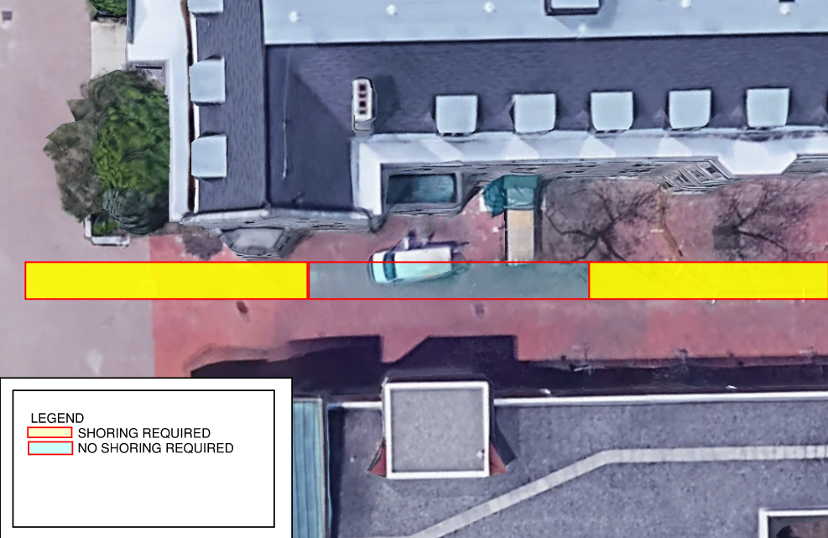

The contractor planned to avoid Tunnel 2 with the equipment, and would drive only over Tunnel 1. Areas where shoring was required to have #2 post shores down the centre of the tunnel at 24” on centre with a maximum 7ft extension. One small area in Tunnel 1 required a longer extension, which required 6-#3 grouped shores, max 16” clear between groups, middle of tunnel, max 12’ extension. Our team review the installation of the shoring and found it was installed appropriately.

We thank you for this opportunity to be of service and we trust that the content of this letter is sufficient for your current needs. Please do not hesitate to contact the undersigned should you have any further questions.

Sincerely,

WALTERFEDY

Kyle Pellerin, P .Eng.
Structural Engineer, Associate
kpellerin@walterfedy.com
519.576.2150 Ext. 418

